Westmoreland Town Board
Public Hearing and Regular Meeting
July 8, 2013

Supervisor Gregory Sydoriw called the Public Hearing regarding Local Law #4 of 2013; Flood Damage Prevention to order at 6:16 P.M. July 8, 2013 at the Westmoreland Town Hall, 100 Station Road, Westmoreland, New York, with the following Board members present; Councilpersons Hubert Pritchard, Kenneth Eisnor, Charles Hebbard and David Husted. Also present at this meeting were Town Attorney Gregory Mattacola, Highway Superintendent Carl Eddy, Senior Library Clerk Riley McFadden, Codes Officer Terry Williamson, Sole Assessor Bernard Szarek and seven (7) residents.

The Supervisor asked the Deputy Town Clerk Beverly Merriman to read the legal notice as it appeared in the Rome Sentinel on June 27, 2013. The Deputy Town Clerk read:

“NOTICE OF PUBLIC HEARING, Town of Westmoreland
Proposed Local Law for Flood Damage Prevention as Authorized by the New York State Constitution, Article IX, Section 2 and Environmental Conservation Law, Article 36
PLEASE TAKE NOTICE that a Local Law has been introduced in the Town Board of the Town of Westmoreland for Flood Damage Prevention in the Town of Westmoreland, County of Oneida, State of New York.
Said proposed law in general terms provides for the adoption of the new Flood Insurance Study and Flood Insurance rate maps, which were completed by the Federal Emergency Management Agency, into the Town’s floodplain management regulations.
NOTICE IS HEREBY GIVEN that the Westmoreland Town Board will hold a Public Hearing at 6:15 PM, Monday, July 8, 2013, at the Westmoreland Town Hall, 100 Station Road, Westmoreland, New York, to discuss the implementation of floodplain management measures for the Town of Westmoreland.
All interested parties will be heard at this time.”

Supervisor Sydoriw explained to the audience that F.E.M.A has issued new Flood Zone Maps. He stated the flood zones within the Town of Westmoreland are fairly unchanged and asked if the Town Attorney had anything to add.

Town Attorney Gregory Mattacola stated this process is mandated by F.E.M.A. and the Town needs to adopt this local law in order for our residents; residing inside a flood zone; to be eligible for flood insurance. Attorney Mattacola stated the DEC has advised him that approximately Thirty (30) residents will be affected by the new flood zones; however they are not able to identify which thirty (30) residents. He has recently found that the County can provide maps showing the tax map parcels with the flood zones overlaid. He strongly suggested the Town purchase these maps. Once received, individual notifications can be made to those residents affected prior to the September 27, 2013 effective date.

The flood maps were opened and reviewed by anyone interested. Attorney Mattacola clarified that these flood maps are designed to predict where flood insurance would be needed and any financial relief provided by F.E.M.A. in the event of a flood is an entirely separate issue.

The Supervisor asked if anyone had any comments or questions. There be no one wishing to speak, he closed the Public Hearing at 6.35 P.M.

At 6:35 P.M. Supervisor Sydoriw called the regular meeting to order and asked all to stand and join him in the Pledge of Allegiance. He then recessed the regular meeting to allow comments from the floor.

Supervisor Sydoriw introduced Darryl Hogan who has approached the Supervisor about putting a baseball field on the Lowell property.

Mr. Hogan explained that the Town is running out of fields and he would like to put in a regulation field (90 ft) as well as a Little League field on the property. He asked what the Board had in mind for the property, did they foresee a park or a sports complex or any combination thereof. He has had core samples taken already and is eager to get started.

Councilperson Hebbard asked the dimensions of a regulation field. Mr. Hogan replied 300’X 350’. Councilperson Hebbard stated he needed an idea of how much land would be used, including concession stands and dugouts before he would be willing to make any decision. Councilperson Pritchard asked the dimensions of the existing field and was told 280’ from center line.

Councilperson Hebbard asked what the approximate cost was for the large field. Mr. Hogan replied $20,000.00 without fencing. Councilperson Pritchard asked if the backfield fence had to be installed to meet specifications. Mr. Hogan indicated it would not have to be installed.

Supervisor Sydoriw commented that a regulation size field is too one dimensional, meaning it can’t be used for Little League, Minor League or Soft Ball. Mr. Hogan stated he would be willing to entertain a smaller field using Cal Ripkin League specifications of 46’X 60’ for the very young players and 50’X 70’ for the older ones. That, he said would be a very easy retrofit on the existing field.

Codes Officer Terry Williamson asked if any thought had been given to water and bathroom facilities. Mr. Hogan indicated he had not gotten that far.

The Board indicated they were favorable to this suggestion but needed more detailed information including a site plan before any decisions can be made.

The Supervisor asked if anyone else had anything for the Board. Mr. Boylan, Berkshire Drive, told the Board that his home received significant damage from the flooding. He asked what the Board has done or is going to do to get aide. Supervisor Sydoriw stated that there are several areas within the Town that were hard hit. He advised the homeowner to take pictures and document everything. As of right now we have not been declared a state of emergency. If anything comes by his desk he will pass it on, but until the Federal Government declares a state of emergency there are no F.E.M.A. funds available.

A lengthy discussion continued about the causes and effects of area streams and culverts that are plugged or not functioning properly. Councilperson Hebbard and Mr. Michael Johnson gave explanations of the current flooding problems and what needs to be done to correct them. Mr. Johnson asked the Board to advance funds to the Highway Department and authorize them to work on private property to start cleaning out these creeks and culvert pipes.

Supervisor Sydoriw asked the Town Attorney what would be needed for the Town work on private property. Councilperson Hebbard read part of a notice printed from the Governors website stating the rules governing a municipality entering private property have been loosened. A lengthy discussion continued on what needs to be done.

Attorney Mattacola commented that before anything can be done a plan would have to be developed and submitted to the DEC. Discussion continued.

Ed Maxam and Shawn Fitzgerald from Pryor Road stated they are constantly being flooded and wanted to know what action the Town would be taking to correct the problem. They indicated that the problem started when Mr. Burt Seymour filled in a wet area to construct his storage sheds. Water that used to settle in that wet area now runs directly onto their properties.

Mr. Maxam stated that he had a 30” culvert pipe and obtained a permit from the State to replace it with a 60” culvert pipe and he still flooded. Councilperson Hebbard asked Mr. Seymour if there was a way he could redirect the water away from the houses. Mr. Maxam asked for a retention pond to hold the water. Mr. Seymour stated the culverts that go under Pryor Road are not large enough to accommodate all the water. Upstate Home Care is creating a berm to stop their flooding. Discussion continued.

Councilperson Husted spoke of future development and the impact our Planning Board could have on preventing these types of problems from here on out. The Town is only legally permitted to work within the Town right-of-way. While he can understand the frustrations they are experiencing, we can only advise our residents on how to try to rectify the situations.

Highway Superintendent Eddy offered to meet with the Kirkland Highway Superintendent to try to come to an agreement on clearing up the culverts and finalize the ditching on Stop Seven Road. He will put in larger culvert pipes on Pryor Road to accommodate the water run-off and prevent future damage to the road.

There were no County Legislators present. Riley McFadden stated she has spoken with both County Legislators and said they are out driving the roads and assessing the damage. They told her their biggest concern right now is the water main break under the Oriskany Creek.

The Supervisor asked for the Highway Superintendents report. Highway Superintendent Carl Eddy reported:
We have been doing roadside mowing. We have been very busy with all the rain setting up cones where the water has been going over the roads with some shoulder washouts. The Chipper truck has been sold. Most of the road work has been completed.

Councilperson Eisnor commended the Highway Department on the work they have been doing. He stated the Board realizes how hard they have been working and they really do appreciate it.

The Supervisor thanked the Highway Superintendent for his report and asked for the Assessor’s report.

Sole Assessor Bernard Szarek reported that:
I picked up the final roll. I will be trying to go out to do some Data collection this summer on the
parcels that have large inventory to update the cards. I will be attending classes as they come
along. I attended an Ethics class in Rome on June 28.

Supervisor Sydoriw thanked the Assessor and asked for the Codes report.

Codes officer Terry Williamson reported:

Carl Froschauer was issued an Order to Remedy to clean up scrap metal on his Schieferstine
Road residence and he has made significant progress.
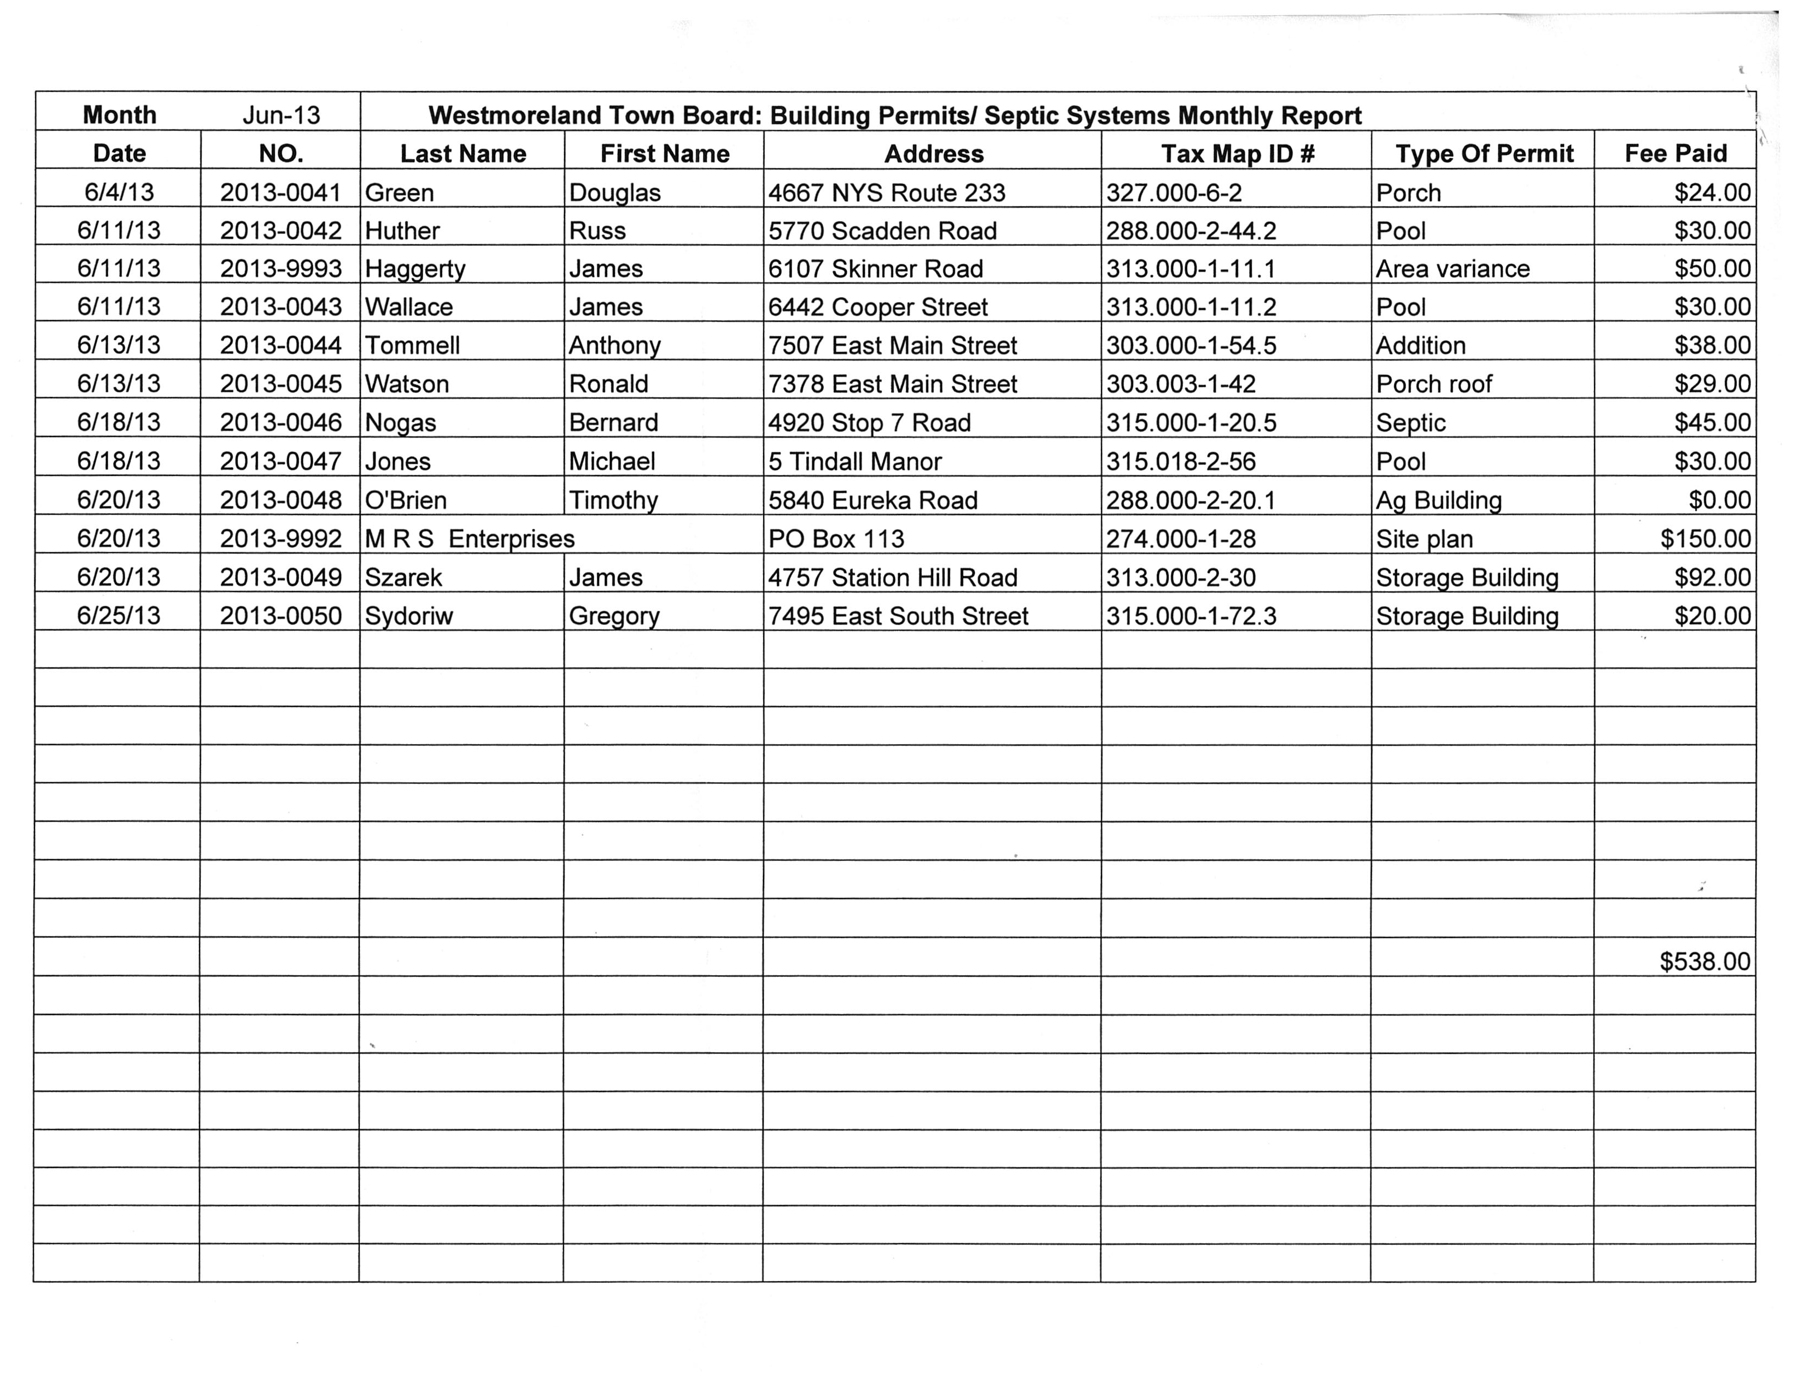

The Codes Officer was thanked for his report and the Supervisor stated there was no Water District Monthly Report, he then asked for the Reading Center Report.

Senior Library Clerk Riley McFadden reported:
In June we loaned out 953 items, registered three new patrons, and purchased twenty-nine new
books for $ 421.77.
Mrs. McFadden added the Summer Reading Program began today entitled “Dig into Reading”

The Supervisor thanked Ms. McFadden for her report, and then asked for the Attorney’s Report.

Town Attorney Gregory Mattacola reported:
- Continued working with the Department of Environmental Conservation and the Federal
Emergency Management Agency (FEMA) on the adoption of Local Law #4.
- Researched amendment to NYS General Municipal Law sec. 50 and drafted resolution to comply with same.
- Reviewed workers’ comp insurance issue.

Attorney Mattacola asked if the Board would like to adopt Local Law # 4 and the Resolution of the Uniform Notice of Claims now.

104 Councilperson Hebbard advanced a motion to adopt Local Law #4, FEMA Flood Zones to take effect on September 27, 2013. The motion was seconded by Councilperson Eisnor. All Board members voted AYE and the Supervisor declared the motion carried.

105 Councilperson Pritchard advanced a motion to adopt the Resolution of Uniform Notice of Claims but remove the individual name and insert the title “Town Clerk”. Councilperson Hebbard seconded the motion. All Board members voted AYE and Supervisor Sydoriw declared the motion carried.

Supervisor Sydoriw called for the Town Clerk’s report.

The Town Clerk reported:
In June, the Town Clerk’s office sold six (6) new dog licenses and renewed sixty-two (62) individual dog licenses, for $498.00. Of that, $78.00 was sent to the Department of Ag & Markets for New York State’s Dog Population Control Program. The Town Supervisor received $420.00, which includes $30.00 in late fees.

On June 4, 2013, we sent out thirty-nine (39) late notices for dog licenses that were due May 31, 2013. Renewal notices, for sixty-eight (68) dogs due in July, were sent out June 27, 2013.

There were three (3) marriage licenses issued in June for $120.00, of which the Town realized $52.50, nine (9) certified copies were issued for $90.00, sale of sporting licenses totaled $97.00 and the Town’s commission is $5.36.

Eight (8) permanent handicapped permits were issued or renewed during the month, of which three (3) were temporary.

Communications received:
- Oneida County Health Dept. - request to join a water taste test competition.
- Dig Safely- notification of changes in billing practices.
- Town of Ulysses Supervisor- request to renew Amicus Curie brief in support of the coalition against natural gas drilling in New York.
- NYS Department of State-information on Consolidated Funding (grant) Application.
- Rome Sentinel-article regarding Angels of Fur moving to Westmoreland.
- Oneida County Health Dept. - updated Drinking Water Advisory Communications Toolbox.
- M.V.E.D.D. - announcement of available resources.
- NYS Environmental Facilities Corporation- information on the Hazard Mitigation Grant Program.
- Cornell University-notice of termination of the Local Technical Assistance Program.

Checks received:
1. Westmoreland Central School fuel 4/30- 5/31 $ 12,482.83
2. Stanwix Heights VFD fuel-May $ 192.72
3. Clark Mills VFD fuel $ 106.35
4. Westmoreland Justice Court Judge Bowers-May $ 8,562.50
5. Westmoreland Justice Court Judge Ossont-May $ 8,442.50
6. Bank of Utica Certificate Interest $ 471.34

Deputy Town Clerk Beverly Merriman advised the Board the Final Assessment Roll has been added to the Town’s website.

Councilperson Ken Eisnor brought up the subject of the Worker’s Compensation Plan and professed his frustrations. He can’t seem to get the answers he is looking for. Attorney Mattacola asked if Councilperson Eisnor had been given any ball park quotes from other carriers. Councilperson Eisnor replied he had been given an estimate of $70,000.00 if we take our claims with us, however it is impossible for anyone to give a factual quote without knowing the entire loss history.

Attorney Mattacola explained how the process worked when the City of Rome left the County Compensation Plan. Discussion continued.

The next topic the Board discussed was the employee’s health insurance plan. Councilperson Eisnor explained the SDCD-12 plan has not been utilized by any employees so that will be dropped this year.
There are two (2) plans being offered again this year, HDHP13 and HDHP14. Both plans were explained and compared to the plans currently offered. The current split is 83% paid by the Town and 17% paid by the employee. Councilperson Eisnor suggested we amend the split to 80% paid by the Town and 20% paid by the employee.

106 Councilperson Eisnor advanced a motion to offer two (2) Health Insurance Plans to Town employees, a HDHP-13 and a HDHP-14, with an 80%-20% split. All Board members voted AYE and the Supervisor declared the motion carried.

Councilperson Eisnor stated open enrollment will commence on Wednesday, August 14, 2013 and our Representative will be providing lunch.

Councilperson Hebbard stated the Pool is open. He met with the new Pool Director, Trevor Morehouse. Mr. Morehouse advised him attendance has been down due to the weather. Councilperson Hebbard and Councilperson Eisnor met with the Mayor of Oriskany and it was agreed Oriskany will pay $1,650.00 up front this year. A statement has been faxed to the Mayor requesting those funds.

Supervisor Sydoriw reviewed the expenditures of the pool fund for 2013, year to date. So far the Town has spent $8,278.33 leaving a balance of 721.67.

Councilperson Husted is working on the LED Street light issues. He has a call into National Grid but they have not returned the call yet.

Councilperson Pritchard asked the Highway Superintendent if he has heard from the engineer regarding the bridge work. Highway Superintendent Eddy replied he hasn’t heard anything. Councilperson Pritchard stated he thinks it’s time we find a new engineer. He then asked about the roof of the salt shed. The highway Superintendent stated he notified M.E.I.D. they were awarded the bid, but again, has not heard any more. Councilperson Pritchard suggested the Town Clerk sent out a formal bid award letter to M.E.I.D.

Supervisor Sydoriw notified the Board that the Water Plant Operator has not produced any bids on the peristaltic chlorine replacement pumps. This item will be tabled until such time that three (3) quotes are produced.

The Supervisor communicated to the Board that the Oneida County Water Association is considering having municipalities provide samples of their water to participate in a water tasting contest at the Oneida County-Booneville Fair. The winner of the taste test would then go on to the New York State Fair. He asked the Board if they wanted to participate. The Board decided that the Town of Westmoreland will participate in the water taste test.

Supervisor Sydoriw relayed to the Board that the Town Clerk would like to put landscaping fabric and top soil on the inside the fence at the Water Treatment Plant. The Board decided that nothing can be done inside the fence, but the Town Clerk can landscape around the outside of the fence.

The Town has received another request from the Towns of Middlefield/Dryden to join in their Municipal Home Rule brief. The Board decided not to participate.

The Supervisor presented the Board with the payroll from January 2013 through June 2013. He asked the Board to review and sign off.

Supervisor Sydoriw advised the Board the Association of Towns meeting will be held on July 16, 2013 at Orchard Hall. Laurie Mithen will be the speaker. Anyone wishing to attend should let the Town Clerk know by July 11, 2013.

There are no budget modifications.

Burt Seymour brought to the Town’s attention that we have a lot of homes in the area that are abandoned and the lawns are overgrown. He wondered if there was anything the Town could do.

Codes Officer Terry Williamson stated if the Town were to mow, we would have to place a lien against the County taxes. Mr. Williamson explained how he contacts the mortgage companies to issue an order to remedy on those properties. He added that if Mr. Seymour has specific properties in mind he should notify the Codes Office.

Supervisor Sydoriw notified the Board that two (2) resumes were received for the ZBA Secretary position, Laurie DeBella and Angela Golden. He gave a brief description of each of their qualifications.

107 A motion was advanced by Supervisor Sydoriw, seconded by Councilperson Eisnor to appoint Laurie DeBella to the position of ZBA Secretary effective July, 8, 2013 through December 31, 2013. All Board members voted AYE and the motion was declared carried.

108 A motion was advanced by Councilperson Eisnor, seconded by Councilperson Pritchard to accept and place on file the Supervisor’s, Town Clerk’s and Codes reports. All Board members voted AYE and the motion was declared carried.

109 A motion was advanced by Councilperson Pritchard to accept and place on file the minutes of May 13, 2013 as written. The motion was seconded by Councilperson Eisnor. Councilpersons Pritchard, Eisnor, Husted and Supervisor Sydoriw voted AYE. Councilperson Hebbard abstained. The Supervisor declared the motion carried.

110 A motion was advanced by Councilperson Pritchard to approve and order paid the claims of the Highway fund, vouchers #128- #151, which total $36,035.12. Councilperson Eisnor seconded the motion. All Board members voted AYE and the motion was declared carried.

111 A motion was advanced by Councilperson Husted, seconded by Councilperson Pritchard, to approve and order paid vouchers #241- #287 of the General fund, totaling $27,649.44. All Board members voted AYE and the motion was declared carried.

112 A motion was advanced by Councilperson Eisnor and seconded by Councilperson Husted to approve and order paid the following Water District vouchers:
Tindall Water Voucher #9 which totals $395.00
Westmoreland Water vouchers #34-#40 which total $2,977.04
Spencer Water vouchers #9-#12 which totals $605.40
Camelot Water voucher #3 which totals $6,497.39
All Board members voted AYE and the Supervisor declared the motion carried.

Supervisor Sydoriw reminded the Board members our next scheduled meeting will be August 12, 2013 at 6:30 P.M.

113 A motion was advanced by Councilperson Hebbard and seconded by Councilperson Eisnor to adjourn this meeting. All Board members voted AYE and Supervisor Sydoriw declared the motion carried and adjourned this meeting at 8:45 P.M.

Respectfully submitted
Jody S. Burdick
Town Clerk

