Westmoreland Town Board
Regular Meeting
April 8, 2013

Supervisor Gregory Sydoriw called the meeting to order at 6:33 P.M. at the Westmoreland Town Hall, 100 Station Road, Westmoreland, New York, with the following Board members present, Councilpersons Hubert Pritchard, Kenneth Eisnor, Charles Hebbard and David Husted. Also present was Highway Superintendent Carl Eddy, Sole Assessor Bernard Szarek, Codes Officer Terry Williamson, Senior Library Clerk Riley McFadden, and seven (7) residents. Town Attorney Gregory Mattacola arrived at 6:35 P.M.

The Supervisor asked all to rise and join him in the Pledge of Allegiance, after which he recessed the regular meeting to allow comments from the floor.

There being no one wishing to speak, Supervisor Sydoriw reconvened to the regular session.

There were no County Legislators present.

The Supervisor called for the Highway report. Highway Superintendent Carl Eddy reported: We have put the new sweeper to work, have been sweeping the roads and it seems to be doing a good job. Weather permitting; we will be cleaning up Main Street soon. We are in the process of servicing the chipper and will begin picking up brush.

We have the old light fixtures and bulbs, wire welder and front mount tractor sweeper and need to decide what should be done with them.

Everyone is back working 7:00 – 3:30 shift. When the weather is bad, we are working on getting the trucks cleaned up and ready to paint.

Supervisor Sydoriw suggested the used equipment could be sold on Ebay through the County. Councilperson Pritchard asked if they were worth anything, he said Burton’s is having an auction this coming Saturday and the Highway Superintendent could take them there. Councilperson Pritchard asked how many light fixtures they had. Highway Superintendent Eddy stated around twenty (20), some of the Highway crew has expressed an interest in them, but were told the Board would have to decide what to do with them. Supervisor Sydoriw stated if anyone wants the lights they can take them, the rest can go to Burton’s and if not sold there, then put it on Ebay.

Superintendent Eddy stated the chipper truck is in really bad shape. It needs two (2) new tires, leaf springs, the motor has numerous oil leaks and the frame has rusted out. He stated it would not pass inspection this year as it was extremely close to failing last year.

Ted Flint and James Wharram will be attending a seminar in Batavia on April 10th and have asked to use a Highway truck for transportation, Superintendent Eddy asked for the Boards opinion. Supervisor Sydoriw responded that he saw no problem with it and Attorney Mattacola concurred.
66 Councilperson Hebbard advanced a motion to take the wire welder and front brush sweeper to Burton’s auction on April 13, 2013 and if not sold there then to place these items on E-bay through the County. Councilperson Pritchard seconded the motion, all Board members voted AYE and the motion was declared carried.

Councilperson Pritchard asked about additional C.H.I.P.’s money the Deputy Highway Superintendent spoke of last month. Superintendent Eddy replied he has not received anything official, but has heard he will receive an additional $24,400.00.

Councilperson Pritchard stated that the additional C.H.I.P.’s money should be earmarked for bridgework and asked if the Highway Superintendent had any update on the bridge specs. Superintendent Eddy answered that he has not had any replies to date.

The Supervisor thanked the Highway Superintendent for his report and asked for the Assessor’s report. Sole Assessor Bernard Szarek reported the tentative role is being completed. Warren put on the Senior Exemptions and the new vets. I worked on the Farm and trailer parks exemptions and as well as the new constructions. I attended the class in Jefferson Community College on March 28th and was able to ride up with the Highway Superintendent, thus saving the mileage cost.

Supervisor Sydoriw thanked the Assessor for his report and asked for the Codes report. Codes Officer Terry Williamson reported the following permits were issued in the month of March:

Month Mar-2013 Westmoreland Town Board: Building Permits/ Septic Systems Monthly Report
Date NO. Last Name First Name Address Tax Map ID # Type of Permit Fee Paid
3/12/13 2013-0007 Madonia Scott 6564 College Hill Road 335.000-2-18.5 Ag. Building N/A
3/19/13 2013-0008 American Tower Corp 6064 Schieferstine Road 287.000-1-18.1 Cell Tower Retro $150.00
3/19/13 2013-0009 American Tower Corp 6590 Daily Road 301.000-2-11.1 Cell Tower Retro $150.00
3/26/13 2013-0010 Portzeba Edward 4919 NYS Route 233 314.000-1-34.8 Entrance Cover $20.00
3/26/13 2013-0011 Seymour Burt 7452 NYS Route 233 327.000-6-41.3 Demolition $25.00
3/26/13 2013-0012 Seymour Burt 7452 NYS Route 233 327.000-6-41.3 Garage $44.00

Councilperson Hebbard asked about Burt Seymour’s request to extend Seymour Lane to Creaser Road. Codes Officer Williamson replied that he had not heard anything more.

Supervisor Sydoriw stated that he spoke with Water Plant Operator Ted Flint and everything is fine with the water department. Both Ted Flint and James Wharram will be attending training on April 10, 2013.

Senior Library Clerk Riley McFadden reported in March we loaned out 1,032 items, registered two new patrons, and purchased nine new books for $146.21. Mrs. McFadden added that the T-shirts for her Summer Reading Program have arrived.

Town Attorney Gregory Mattacola reported he reviewed reporting requirements with New York State and Local Retirement System, review Chapter 95 of the Town General Code and assisted Clerk in contacting residents who are behind on dog licensing fee, reviewed correspondence from General Code and talked to them about lowering their fee and researched legality of annual employee physical examination.

Councilperson Hebbard asked the Attorney about the hydro-fracking ban. Attorney Mattacola reiterated that it would require changes to the current Zoning Laws. Supervisor Sydoriw suggested the Planning and Zoning Boards start the process. He stated he would speak to both Chairmen to initiate, review and make recommendations to the Board as to the changes in the laws needed to implement a ban.

Councilperson Eisnor asked the Attorney if he had the map to the Lowell property. Attorney Mattacola apologized and said he did not.

Councilperson Pritchard asked if Attorney Mattacola had heard anything back from General Codes in regard to their fees to add the news laws to the Codification. Attorney Mattacola stated he did speak with them and they have dropped their fee from $700.00 to $400.00 for the addition of the one new law. The Attorney suggests that we wait and update the Codification every one or two years. The Board agreed.

Town Clerk Jody Burdick reported in March, the Town Clerk’s office sold twelve (12) new dog licenses and renewed fifty-nine (59) individual dog licenses, for $570.00. Of that, $83.00 was sent to the Department of Ag & Markets for New York State’s Dog Population Control Program. The Town Supervisor received $487.00, which includes $110.00 in late fees.

Attorney Mattacola wrote a letter to nineteen (19) dog owners who were in violation of renewing their dog’s license. Of these, twelve (12) responses were received, nine licenses were renewed, which accounts for the $110.00 in late fees collected and three (3) dogs moved out of Westmoreland.

On March 7, 2013, we sent out sixteen (16) late notices for dog licenses that were due February 28, 2013. Renewal notices, for sixty-one (61) dogs due in April, were sent out March 28, 2013.

There was one (1) marriage license issued in March for $40.00, of which the Town realized $17.50, five (5) certified copies were issued for $50.00, one (1) junkyard license was issued for $25.00 and two (2) fishing licenses were sold for $58.00, the Town received $3.20 in commission.

Seven (7) handicapped permits were issued or renewed during the month, of which one (1) was temporary.

On March 2, 2013, we held the second Red Cross Blood Drive of the year. We had nineteen (19) regular donors and four (4) double red donors for a total of twenty-seven (27), missing the goal of thirty-one (31).

On March 18th, the Town Clerk traveled to Latham NY to attend the NYSTCA Regional meeting. The Speaker was Laura Rodolakis, CPA with the NYS Office of the Comptroller, who spoke on the Financial Accountability of Town Clerks.

Communications received:
- Family of Rethea Storey- thank you note for the Towns Humane Society donation.
- Oneida County Board of Legislators- notice of Public Hearing regarding Agricultural Districts.
- Danae Donatello- thank you to the Supervisor for meeting to discuss Parks and Recreation.
- MVEDD- invitation to Grant/Funding Opportunities luncheon.
- Nancy Pritchard-Historian’s Report for March 2013.

Checks received:
1. Westmoreland Central School fuel 12/31-2/3 $ 16,860.09
2. Time Warner Cable franchise fees $ 13,482.94
3. Time Warner Cable franchise fees $ 6,437.17
4. COVAC fuel 2/3-3/4 $ 2,780.37
5. Clark Mills Fire Dept. fuel $ 120.14
6. Westmoreland Fire Dept fuel 2/3-3/4 $ 991.48
7. Westmoreland Justice Court Judge Bowers- Mar $ 11,040.00
8. Bank of Utica cert. interest $ 461.10

The Town Clerk told the Board that Deputy Town Clerk Beverly Merriman is the recipient of two (2) scholarships totaling $600.00 to attend the NYSTCA Conference. Both Jody and Beverly will be attending conference April 30 through May 1, 2013.

The Town Clerk also noted that the Attorney’s letter to late renewal dog owners was very successful. Of the nineteen (19) names submitted to the Attorney, only three (3) have yet to respond.

Supervisor Sydoriw referenced the thank you letter in the Communication folder from Danae Donatello. He said she has since called to advise him she received an A+ on the paper she wrote on their interview.

The Supervisor stated the Park is now open, including the restrooms. A slide has been vandalized and has a crack and a hole in it. Lynn Johnson, Park Maintenance, has taped it off and placed an out of order sign on it. Supervisor Sydoriw stated the Supervisors Clerk will obtain estimates for a new one and Mike Rolewicz will be looking at it as he can sometimes repair this type of plastic.

The Supervisor brought up the subject of security cameras at the Town Park and asked the Board members if this was something they still wanted to do. Lynn Johnson told the Supervisor that New Hartford installed high power poles and placed security lights on top to illuminate the whole park. He fears children may attempt to climb up to disable the security cameras. Councilperson Hebbard stated he is still in favor of the security cameras. The vandalism in the area is on the increase and cited an incident where metal bleachers were stolen from the little league field behind his house. Councilperson Pritchard commented that if something like can happen in broad daylight, security cameras at night will not solve anything. Councilperson Hebbard rebutted that some of the incidents that have occurred in the park are dangerous to other park users. He feels something is better than nothing. Councilperson Eisnor agreed that it will be very hard to identify an offender from a security camera. Councilperson Hebbard suggested we have the security company who provided the quote last fall come and give a presentation to the Board.

Sole Assessor Bernard Szarek suggested the Board purchase several infrared trail cameras to put in the Park. He has also had trouble with theft, and that is what he intends to do this year.

Supervisor Sydoriw brought up the subject of the use of Highway vehicles going to and from work by the Highway Superintendent and the Deputy Highway Superintendent. He stated he just can’t justify taking the Town Trucks home during the summer months. Councilperson Eisnor disagrees stating this is a perk that goes with the job. Councilperson Pritchard indicated that it has been a perk forever but the IRS law indicates a 1099 should be issued if the use of the vehicle exceeds $600.00. Councilperson Hebbard also indicated he disagrees because the Highway Superintendent and his Deputy don’t just drive to and from work. They take alternate routes each day looking at the road conditions, work in progress and the general appearance of the Town’s roads. He continued stating in the event that they are called out in the middle of the night, they should have a Town vehicle at their disposal. Councilperson Husted commented that he agrees the Highway Superintendent should have a vehicle year round, but his Deputy should only have one in the winter months.

Councilperson Pritchard brought up the subject of the pothole condition on Shed Road and the surrounding area. He had mentioned one to the Deputy Superintendent and it was filled the next day. There are several others that have not been attended to. He said he is aware the Highway Department has been out working on the roads and can’t understand why they are not reporting this back to the Highway Superintendent. Councilperson Pritchard suggested the Highway Superintendent make it known to his employees that this is a job requirement.

Councilperson Pritchard asked if the disciplinary problems that were discussed in January had improved at all. Highway Superintendent Eddy replied there has been no improvement.

Councilperson Eisnor spoke with Frank Conestabile from Rising Stars who is looking for a place to put new soccer fields. He is interested in the Lowell property. Councilperson Eisnor indicated there are three (3) different options to consider in doing this;
- lease it for the Summer and Rising Stars would put in three (3) fields
- sell the property to Rising Stars
- Rising Stars would build a pavilion for the public’s use in lieu of any form of payment
Frank indicated that he would be willing to come and discuss this with the Board at any time. Discussion continued.

Councilperson Eisnor moved on to the generator issue. He explained he met with the electrician and because each of the buildings is powered by different transformers; one generator will not service both buildings. Discussion commenced and Councilperson Pritchard indicated the Board may want to reconsider their decision to purchase a natural gas powered generator. He feels it will not be cost effective to have to hook into a gas line considering how seldom the unit would be used.

Councilperson Eisnor suggested a special meeting on May 6, 2013 at 6:00 P.M. and to have both Rising Stars and Electrician Rick Bearse come to discuss all options on both the Lowell property and the generator so that the Board can finally come to a decision. Supervisor Sydoriw agreed and asked the Town Clerk to advertise for the special meeting.

Councilperson Eisnor asked the Board to review the Pool Handbook and a procedure on how they are going to handle their finances going forward. He indicated this was a start but still feels they are very dysfunctional. He was told Robert Otter, the maintenance man, refuses to return their phone calls and has the only key to the pump house and the only manual to the pump. Councilperson Pritchard stated the pump was purchased through Mary Shepherd’s business, BGM Supply.

Community Recreation’s President Mike Calogero advised Councilperson Eisnor that the Director, Jennifer Sabino has resigned. Councilpersons Eisnor and Hebbard will be meeting with the Pool Association on Wednesday night, April 10, 2013 at 6:30 P.M if anyone would like to attend. Discussion continued and Councilperson Eisnor suggested the Town take over the Pools payroll and have Payroll Clerk, Diane Rolewicz do it. He also suggested the Town purchase a laptop and payroll program specifically for the pool. Supervisor Sydoriw stated they should be looking for a laptop for the Supervisor’s office.

Attorney Mattacola stated that he doesn’t feel the Town can just take over the financials of the Community Pool Association as they are a separate entity. Discussion continued and Councilperson Eisnor indicated that he is on the Association’s Board. Under those circumstances, Attorney Mattacola felt the Town could process the financials with the Community Recreation Associations agreement.

Supervisor Sydoriw indicated that if the pool is not open to suggestion from the Board and things don’t drastically change, he feels the pool should not open this year. Discussion continued.

Councilperson Hebbard relayed to the Board that he went to six (6) of the seven (7) houses on East Main Street to determine if those residents wanted the Town to extend the lighting district to Stop 7 Road. Five (5) of the six (6) residents stated they did NOT want it. They don’t feel there is a need for it and they don’t want to pay for it. Therefore it is a non-issue. Councilperson Husted asked if Pedestrian and Bike traffic signs could be placed at the Stop 7 and Main Street intersections.

Councilperson Pritchard brought up Mohawk Valley Water Authority and the Canal Corporations agreement to release more water. He spoke with two people from Mohawk Valley Rural Development who advised there is money out there but no grants, only low interest loans. He also spoke with the Town of Kirkland and they advised him they have not been able to find any incentive to do anything. Councilperson Hebbard apologized as he has not contacted Carolyn Williams regarding grants.

Supervisor Sydoriw was contacted by a resident on Lowell Road who has been in contact with Pat Betcher, he is going to contact the Supervisor regarding extending the water district up Lowell Road past Creaser Road. Councilperson Pritchard stated that where the line ends now is the extent of the current water pressure that the Westmoreland Water District can produce. Councilperson Pritchard feels the Town is in more of a need for water or a new well than a generator.

Councilperson Pritchard commented on the historians report indicating the County Historical Society will be meeting here on June 8, 2013. Town Historian Nancy Pritchard would appreciate it if someone from the Town Board would be here to greet them. Supervisor Sydoriw stated that would be a good job for Councilperson Pritchard.

Senior Library Clerk Riley McFadden said the Village of Whitestown did send notification of their bicentennial celebration to the Westmoreland Historical Society.

Supervisor Sydoriw stated the Board needs to approve the Standard Workday Resolution as follows:
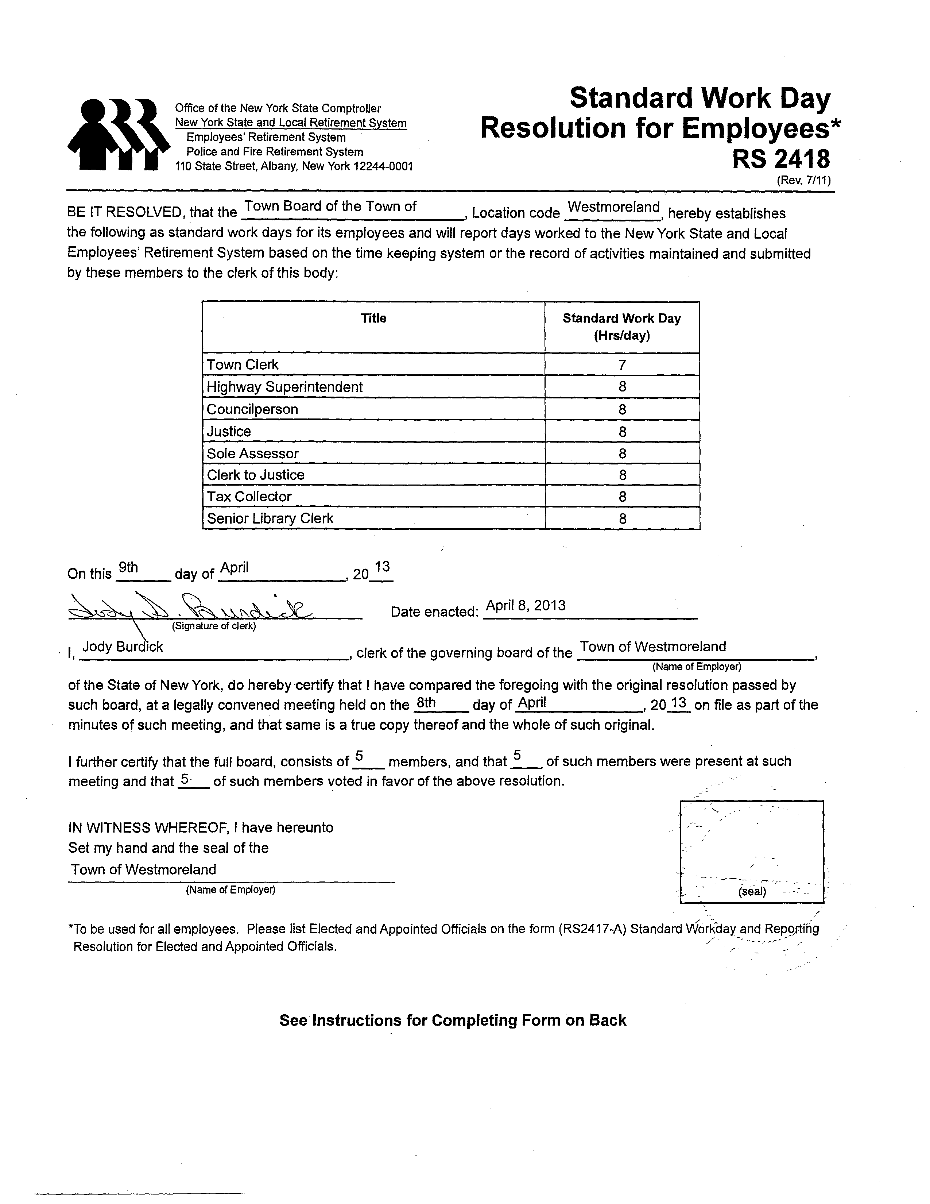

67 A motion was advanced by Councilperson Eisnor, seconded by Councilperson Hebbard to approve the 2013 Standard Workday Resolution. All Board members voted AYE and the Supervisor Declared the motion carried.

Supervisor Sydoriw advised the Board that the Supervisors Clerk Vikki Parent has been working with Gary Schreppel on the unpaid fire inspections. As it turns out there were only three (3) businesses that had not paid for their inspection. Letters were sent and one (1) business, Nice & Easy, has since paid.

The Supervisor told the Board we still have not received a response from Assemblyman Blankenbush on the Resolution concerning the two (2) foreclosure bills we questioned him on. Councilperson Eisnor stated he also followed up with an e-mail and did not get a response. Councilperson Pritchard suggested we take no action on the resolution and Councilperson Hebbard concurred.

Supervisor Sydoriw mentioned there have been several meetings regarding the Oneida County Mitigation Plan, which he has been unable to attend. He will meet with Joanne on Wednesday April 10, 2013 and she will bring him up to date. She told him to plan on meeting for one (1) hour.

The Supervisor acknowledged the letter to Assemblyman Blankenbush; offering him office space in the Town Hall; that was circulated while he was on vacation. He stated he does not have a problem with this but wanted to discuss this with the Board before he signed. He asked where, if he decides to come, we would set him up. Councilperson Eisnor stated that when he met with the Assemblyman and George Joseph last fall, he was shown Vikki Parent’s office. Vikki would share an office with the Water Clerk, Lynnette Vanbenschoten. Councilperson Pritchard asked if this office space we were offering was free. Supervisor Sydoriw replied that Assemblyman Blankenbush has a small budget for a satellite office. Councilperson Husted found a typographical error in the letter and the Supervisor called for a five (5) minute recess to allow the Town Clerk to correct it.

The Supervisor called the meeting back to order at 8:25P.M. A corrected letter was produced and all Board members signed it.

The Supervisor reminded the Board members the Association of Towns meeting will be held at the Marble Hill Inn on April 16, 2013 at 6:00 P.M. Anyone wishing to attend should let the Town Clerk know no later the Friday, April 12, 2013.

The Supervisor told the Board members that they have been provided with the following information on training:
1. An Audit Seminar at SUNY IT, Tuesday April 30, 2013 at 6:30 P.M
2. Grant and Funding Opportunities will be given by Mohawk Valley Economic Development District on Wednesday, April 24, 2013 at 12:00 P.M.

The Supervisor relayed that he received a letter from Rome Water Commissioner, Frank Talerico. The letter stated that Camelot Water district is providing water to 6425 and 6410 Bartlett Road. They are receiving water in exchange for allowing Camelot to run their sewer lines through their properties. Mr. Talerico indicated this was fine but stated that there are (3) additional properties on State Route 233 that have hooked up to the water. Supervisor Sydoriw state these three (3) houses would be before the meter. As it turns out all three (3) properties are in the Town of Whitestown and therefore not our problem. The Supervisor will inform Mr. Talerico.

The Supervisor asked the Board members to review and sign the March Cash Disbursement Journal for the Bookkeeper. All Board members signed the Cash Disbursement Journal.

Supervisor Sydoriw received information from FEMA regarding the Town adopting a Local Law on Floodplain Management Regulations. A draft local law must be submitted by June 20, 2013. This information was turned over to the Town Attorney.

Councilperson Eisnor asked if the Board intended to implement the same rules and regulations to the Lowell property as we currently have in place for the Town Park. The Supervisor stated there is nothing there yet so no rules are needed.

68 a motion was advanced by Councilperson Hebbard, seconded by Councilperson Eisnor to approve and place on file the Supervisor, Town Clerk and Codes reports. All Board members voted AYE and the motion was declared carried.

69 Supervisor Sydoriw advanced a motion to accept and place on file the minutes of March 11, 2013 as written. Councilperson Pritchard asked that the statement made by Jonathan Barns regarding the Public Hearing for a Hydro-fracking moratorium be clarified. Supervisor Sydoriw amended his motion to include the above clarification. All Board members voted AYE and the motion was declared carried.

70 A motion was advanced by Councilperson Eisnor, seconded by Councilperson Husted to approve and order paid the claims of the Highway Department, vouchers #60-#81 totaling $28,099.52. All Board members voted AYE and the Supervisor declared the motion carried.

71 Councilperson Husted advanced a motion to approve and order paid the General Fund, vouchers #106-149, totaling $33,326.92. This motion was seconded by Councilperson Eisnor. All Board members voted AYE and the motion was declared carried.

72 Councilperson Hebbard advanced a motion to approve and order paid the vouchers of the Water Districts as follows:

Tindall Water vouchers #3-#6 which total $ 853.18
Westmoreland Water Vouchers #18-#25 which total $2,269.18
Spencer Settlement vouchers #5-#8 which total $ 523.52
Camelot voucher #2 which totals $8,797.64

The motion was seconded by Councilperson Husted. Councilperson Pritchard question the amount of billed water usage for Camelot. He asked the Town Clerk to call the Rome Water Department and get clarification. All Board members voted AYE and the Supervisor declared the motion carried.

Councilperson Pritchard asked the Sole Assessor how many users are in Camelot. The Sole Assessor Bernard Szarek replied approximately 160.

The Supervisor announced a Special Meeting will be held May 6, 2013 at 6:00 P.M. to discuss the purchase of a generator with Electrician Rick Bearse and to discuss with the Board members of Rising Stars the possibility using the Lowell Property for soccer fields. The next Regular Board Meeting will be held May 13, 2013 at 6:30 P.M.

73 A motion was advanced by Councilperson Pritchard and seconded by Councilperson Hebbard to adjourn this meeting. All Board members voted AYE and the Supervisor declared the motion carried and adjourned the meeting at 8:50 P.M.

Respectfully Submitted,
Jody S. Burdick
Town Clerk

